**Assignment 02**

1. **Write a query that produces all rows from the Customers table for which the salesperson’s number is 1001.**

**Ans :**

SELECT * FROM customers WHERE snum = 1001;

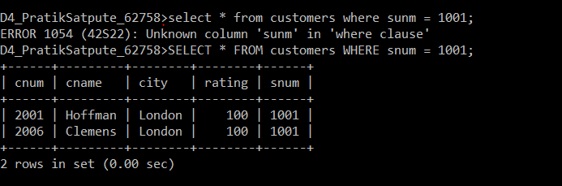

1. **Write a select command that produces the rating followed by the name of each customer in San Jose.**

**Ans :** SELECT rating, cname, city FROM customers where city = 'San Jose';

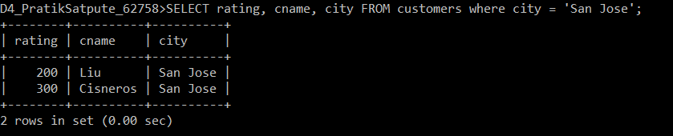

1. **Write a query that will produce the snum values of all salespeople from the Orders table (with the duplicate values suppressed).**

**Ans** : Select * from salespeople order by snum;

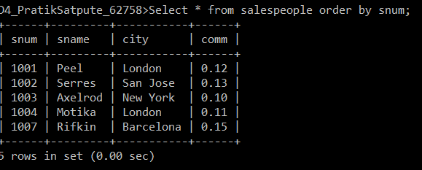

1. **Write a query that will give you all orders for more than Rs. 1,000.**

**Ans** **:** select * from orders where amt >=1000;

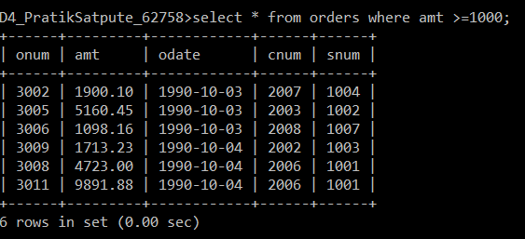

1. **Write a query that will give you the names and cities of all salespeople in London with a commission above 0.10.**

**Ans :** select sname, city from salespeople where city = 'london' AND comm>=0.10 ;

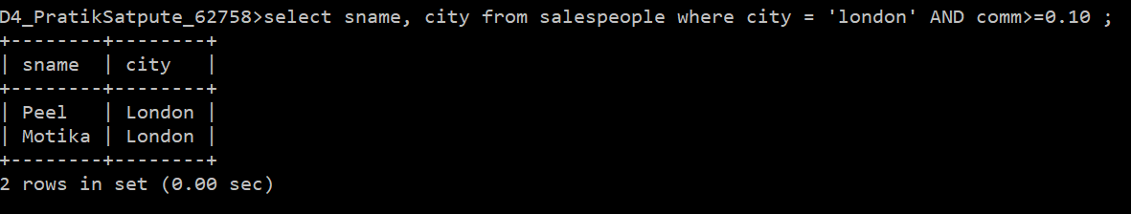

1. **Write a query on the Customers table whose output will exclude all customers with a rating <= 100, unless they are located in Rome.**

**Ans** : Select * from customers where rating >100 OR city = 'rome';

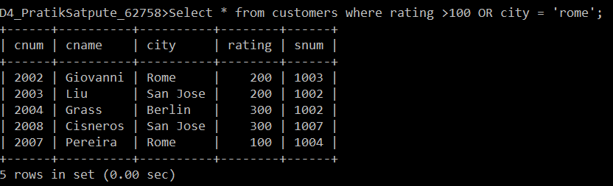

1. **What will be the output from the following query?**

**Select * from Orders where (amt < 1000 OR NOT (odate = '1990-10-03' AND cnum > 2003));**

**Ans :**

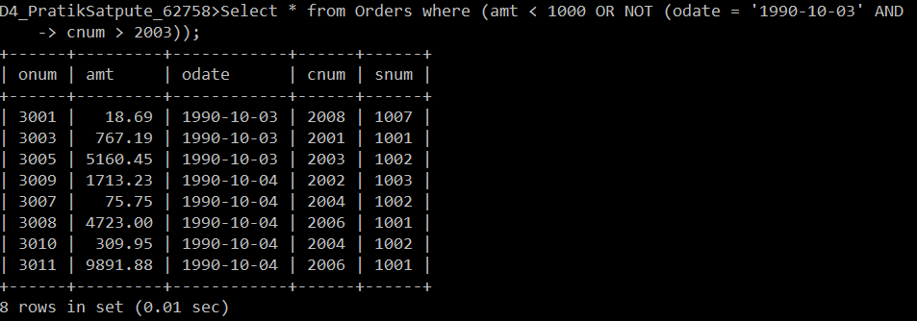

1. **What will be the output of the following query? Select * from Orders where NOT ((odate = '1990-10-03' OR snum >1006) AND amt >= 1500);**

**Ans:**

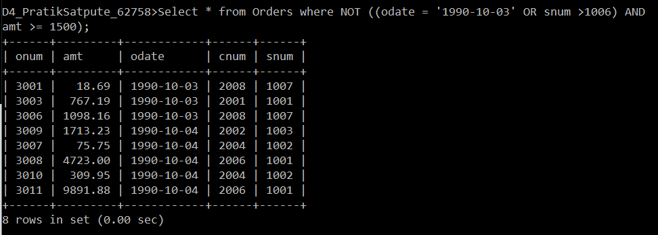

1. **What is a simpler way to write this query? Select snum, sname, city, comm from Salespeople Where (comm >= .12 or comm <= .14);**

**Ans:** Select * from salespeople where (comm >= .12 or comm <= .14);

1. **Write a query that selects all of the customers serviced by Peel or Motika. (Hint:the snum field relates the two tables to one another).**

**Ans.** Select * from customers where snum = 1001 OR snum = 1004;

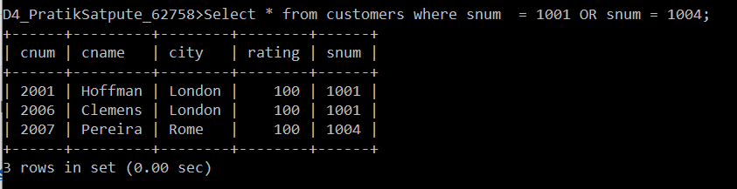

1. **Write a query that selects all orders except those with zeroes or NULLs in the amt field.**

**Ans :** Select * from Orders where amt is not null;

